Our Standards for this week are…
Reading | RI1.5 Explain major differences between books that tell stories & books that give information, drawing on a wide reading of a range of text types.  L1.2d Use conventional spelling for words with common spelling patterns & for frequently occurring irregular words.  RL1.6 Identify who is telling the story at various points in a text.  Read Aloud: The Three Little Pigs, The Princess and the Pea  Vocabulary: voice, dialogue  Sight Words: words, who, eve  Letterland: more words with’or’
Writing | W1.1 Write opinion pieces in which they introduce the topic or name the book they are writing about, state an opinion, supply a reason for the opnion, and provide some sense of closure  Vocabulary: characteristics (things that we are/have)
Sci | 1L.2 Summarize the needs of living organisms for energy & growth.  Vocabulary: life cycle, mammal
Math | 1OA.1 Use addition & subtraction within 20 to solve word problems involving situations of adding to, taking from, putting together, taking apart, & comparing.  1. OA6 Add & subtract within 20, demonstrating fluency for addition & subtractions within 10. Use strategies such as counting on; making ten (8+6=8+2+4); decomposing a number leading to a ten (13-4=13-3-1); using the relationship between addition & subtraction; & creating equivalent but easier or known sums (7+6=6+6+1)  Vocabulary: compare (how many more, how many fewer)
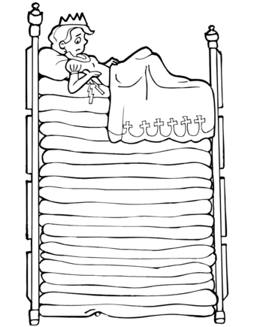
This week we will…
…continue exploring first person point of view by acting out The Three Little Pigs.
...read The Princess & the Pea & discuss the different character points of view.
…use commas in our writing when creating lists.
…thinking about characteristics, we will reflect on ‘our best parts’ & write opinion pieces to reflect our feelings
…learn more words that have ‘or’.
…collaborate with a team to build a house strong enough to withstand a “big bad wolf”.
…compare quantities found within word problems to find ‘how many more’ or how many fewer’.
…begin an exploration of different types of animals and their characteristics.
… bring our green beans or geraniums home to watch them grow!
…have fun learning!

Pictures: we are missing payments and/or pictures from multiple students. If you have spring pictures at home please return them or send in your payment ASAP if you haven’t done so already.
FUN RUN – April 21st from 1-1:30pm (our recess time) we will be participating in the Track 2 & 4 Fun Run. Each grade level competes against themselves to see who can run the most! Winners will be announced. Please come dressed appropriately for physical activating. We will be running on the middle school track. If weather permits, please wear shorts, tshirts, and athletic shoes WITH socks. Also, please start thinking about applying sunscreen or providing your little one with a hat for the upcoming hot recess afternoons!
Mark Your Calendars

April 13th
Book Fair begins

April 14th
No School

April 18th
Raleigh Night

April 21st
Fun Run, 1-1:30

April 17th –- Wacky Week

Wish List
Hand Sanitizer
Clear Sheet Protectors

Weekly HomeWork Assignments
Monday (PE)  Letterland: read and spell words 3x  Math: ---  Read Take Home Book; add to log | Tuesday (Media)  Letterland: Read words & Look-Say-Cover-Write Sheet  Math: worksheet  Read Take Home Book
Wednesday (Art)  Letterland: Write 5 Sentences  Math: worksheet  Read Take Home Book | Thursday(PE)  Letterland: Practice Test  Math: ----  Read Take Home Book

Friday:
NO SCHOOL
Books We Read
-The True Story of the Three Little Pigs, The Three Little Pigs
Fechas importantes

jueves , 24 de marzo
La nieve día

Viernes, marzo 25- Viernes 4 abril
Vacaciones de primavera, no escuela

miércoles , 6 de abril
El campo de viaje mármoles

