What are we learning this week?!
Reading | RL1.1 I can ask and answer questions about details in a text.  RL1.2 I can retell a story including important details and the lesson of the story.  RL1.7 I can use pictures and details to describe the characters, setting and events of a story.  Sight Words:  Vocabulary: “sassy”, “bossy”, The Recess Queen
Writing | W3 I can sequence atleast 2 events in a story; include details that tell what happened, include expressions, and add an ending.  Vocabulary: detail, landscape
S.S. | C&G1.1 I can explain why rules are needed and I can discuss jobs and roles in the community, school, and home.  Vocabulary:
Math | NBT1 I can count to 120, starting at any number less than 120. I can read and write numerals and represent a numeral using drawings, objects, etc. in multiple ways.  Vocabulary: subitizing, math mountain
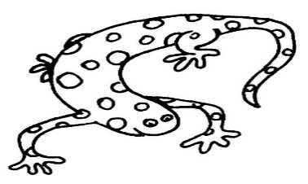
From your teacher…
Welcome back to our Track 1 friends! Because of the extra 1st grade classes back in school and Coach tracked out we will only have a rotation of Music, Art, and Media for Specials. On the days we do not have a special we will utilize this time in implementing STEM projects, reading extra stories, learning more about SeeSaw, and so much more! Can’t wait to share it all with you!

Mark Your Calendars

Friday, August 19th
Early Release

August 22-September 9
Track Out

Monday, September 12
Track In

Thursday, November 10
Early Release
Friday November 11
No School

In the Know….
Reading logs: Fill in your reading log in your ANCHOR book whenever you read a book. It does not matter the level! If your little one is reading Chapter Books, please put down each chapter individually. This is meant to be a place to help your little one make reading goals, not another thing to add to your plate.
Congratulations to those students that are already on their second log!!

Wish List
white cardstock

Weekly Homework Assignments
Monday (---)  Letterland: Read 2x  Math: Rep. Very large sets  Read, add to Reading Log | Tuesday (Music)  Letterland: Look-Say-Cover-Write-Check  Math: --  Read, add to Reading Log
Wednesday (Art)  Letterland: Write 5 sentences  Math:  Read, add to Reading Log | Thursday (Media)  Letterland: Spelling Test  Math:  Read, add to Reading Log

Fechas importantes

jueves , 24 de marzo
La nieve día

Viernes, marzo 25- Viernes 4 abril
Vacaciones de primavera, no escuela

miércoles , 6 de abril
El campo de viaje mármoles

Friday:
---

Books We Read
-The Dot by Peter Reynolds

