What are we learning this week?!
Reading | RL1.1 I can ask and answer questions about details in a text.  RL1.2 I can retell a story including important details and the lesson of the story.  RL1.7 I can use pictures and details to describe the characters, setting and events of a story.  Sight Words:  Vocabulary: “fiercely”, Lilly’s Purple Plastic Purse
Writing | W3 I can sequence atleast 2 events in a story; include details that tell what happened, include expressions, and add an ending.  Vocabulary: punctuation
S.S. | C&G1.1 I can explain why rules are needed and I can discuss jobs and roles in the community, school, and home.  Vocabulary: growth mindset
Math | 1OA1 I can use addition and subtraction within 20 to solve word problems involving adding to, taking from, putting together, taking apart, and comparing, with unknowns in all positions, e.g., by using objects, drawings, and equations with a symbol for the unknown number to represent the problem  Vocabulary: addition, subtraction, 10 Frame
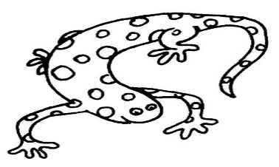
From your teacher…
We have had a few ‘accidents’ of various kinds. Please send in a full change of clothes for your little one. Please have each item labeled with your child’s name and put it in a labeled ziplock bag. Accidents happen, and sometimes it’s nice to have a fresh change of our own clothes. Thank you in advance for helping us with this!

Mark Your Calendars

Friday, August 19th
Early Release

August 22-September 9
Track Out

Monday, September 12
Track In

Thursday, November 10
Early Release
Friday November 11
No School

The more that you read, the more things you
will know. The more
that you learn, the more places you'll go.

Wish List
Scott Laminating pouches

Weekly Homework Assignments
Monday (Music)  Letterland: Read 2x  Math:  Read, add to Reading Log | Tuesday (Art)  Letterland: Look-Say-Cover-Write-Check  Math: --  Read, add to Reading Log
Wednesday (Media)  Letterland: Write 5 sentences  Math:  Read, add to Reading Log | Thursday (--)  Letterland: Spelling Test  Math:  Read, add to Reading Log

Fechas importantes

jueves , 24 de marzo
La nieve día

Viernes, marzo 25- Viernes 4 abril
Vacaciones de primavera, no escuela

miércoles , 6 de abril
El campo de viaje mármoles

Friday:
Music

Books We Read
- The Recess Queen

