What are we learning this week?!
Reading | RL1.1 I can ask and answer questions about details in a text.  RL1.2 I can retell a story including important details and the lesson of the story.  RL1.7 I can use pictures and details to describe the characters, setting and events of a story.  Sight Words:  Vocabulary: “experiment”, “discovered”, The Dot
Writing | W3 I can sequence atleast 2 events in a story; include details that tell what happened, include expressions, and add an ending.  Vocabulary: detail, landscape
S.S. | C&G1.1 I can explain why rules are needed and I can discuss jobs and roles in the community, school, and home.  Vocabulary: growth mindset
Math | 1OA1 I can use addition and subtraction within 20 to solve word problems involving adding to, taking from, putting together, taking apart, and comparing, with unknowns in all positions, e.g., by using objects, drawings, and equations with a symbol for the unknown number to represent the problem  Vocabulary: less than, greather than, counting on
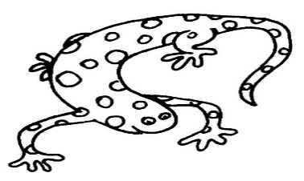
From your teacher…
Great job on homework last week! I really saw a tremendous improvement in our letterland assessment on Friday. We are practicing using these words in our writing and the sentence writing practice is very important. Try and make your sentences more creative and add more detail. We’ve talked a lot about adding detail to our sentences to make them more interesting!

Mark Your Calendars

Friday, August 19th
Early Release

August 22-September 9
Track Out

Monday, September 12
Track In

Thursday, November 10
Early Release
Friday November 11
No School

In the Know….
Town hall: We have Town hall this week. Students will be discussing being “SPOT” on at school and how we can do and be our best every day. I continue to be impressed and so proud of our class for all the SPOTs they are earning in the hallway, cafeteria, and specials for SPOT behavior. In class we will continue talking about having a GROWTH MINDSET and how we may not be able to now, but we’re going to do whatever it takes to learn!

Wish List
Scott Laminating pouches

Weekly Homework Assignments
Monday (PE)  Letterland: Read 2x  Math:  Read, add to Reading Log | Tuesday (Art)  Letterland: Look-Say-Cover-Write-Check  Math: --  Read, add to Reading Log
Wednesday (Media)  Letterland: Write 5 sentences  Math:  Read, add to Reading Log | Thursday (PE)  Letterland: Spelling Test  Math:  Read, add to Reading Log

Fechas importantes

jueves , 24 de marzo
La nieve día

Viernes, marzo 25- Viernes 4 abril
Vacaciones de primavera, no escuela

miércoles , 6 de abril
El campo de viaje mármoles

Friday:
Art

Books We Read
- Stand Tall Molly Lou Mellon
- Noise

