What are we learning this week?!
Reading | RI1.6 I can tell the difference between information learned from pictures or other illustrations and information learned from the story/text.  RL1.2 I can retell stories, including key details and share the morel or lesson of the story  Sight Words: cannot, see, over  Vocabulary: copy, practice (The Art Lesson)
Writing | W1 I can write an opinion piece and introduce the topic or name the book I am writing about, state an opinion, supply a reason for the opinion, and add a concluding sentence.  Vocabulary: punctuation
Science | Vocabulary: rocks, sand, silt
Math | NBT2 I can tell that a 2-digit number is made of tens (10s) and ones (1s)  Vocabulary: place value, tens, ones
From your teacher…
Don’t forget to send in a easy to open and quick to eat SNACK every day for your child. Also, please feel free to continue sending a labeled water bottle. This way they can simply refill it at school during the day and especially at recess.

Wish List
-Community Snack
-Hand Sanitizer

IN THE KNOW
---Thank you to those that had already sent in a CHANGE OF CLOTHES to school. Accidents happen and it is so much easier if your child has their OWN clothes in their cubby to change into versus having to send them ALL the way down the hall to the office to hopefully find clothes that might fit them. Please please please send in a weather appropriate change of clothes with socks, underwear, bottoms and tops in a labeled bag.
---READ-A-THON: The Read-a-thon is coming soon!! Kickoff day is 10/10 for T1, 2, 3 and this year's theme is Camp Out with a Good Book. Lots of FUN reading activities will be happening - Book Fair, Family Night, Character Dress-Up and MORE! Informational packets will be sent home this week.
Mark Your Calendars --Key Dates: 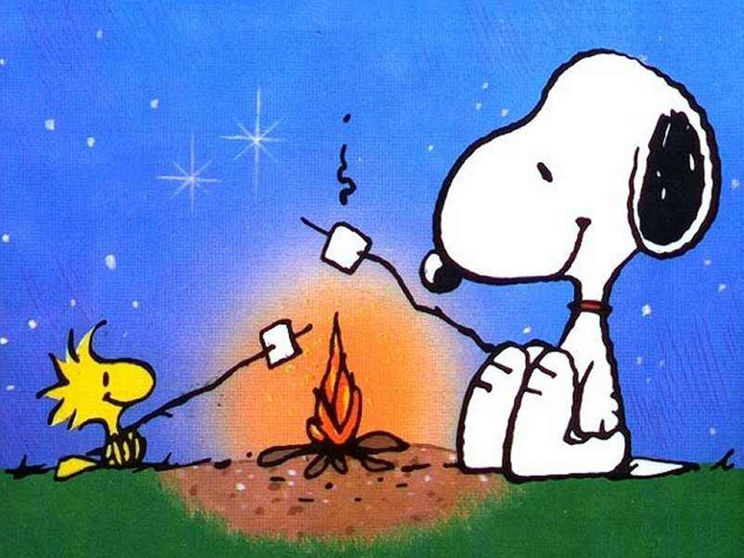
Week of October 3rd - Informational packets sent home
10/10: Kick-off Day - T1,2,3 Mons & Weds: In-class reading for minutes
10/17-10/28: Book Fair 10/20: Dress as your Favorite Character Day T1, 3
10/20: Family Night 11/7: Author Day
11/10: Dress as your Favorite Character Day T2, 4

Mark Your Calendars
Monday, October 10th
Read-A-Thon begins!

Monday October 17th
Book Fair Begins

Friday, October 28th
Make-Up Picture Day

Tuesday, November 8
2- Hour Delay (Doors open at 10:45am)

Thursday, November 10
Early Release

Friday November 11
No School

Books We Read
-Clark the Shark
- National Geo. “Sharks”
- When the Leaf Blew In

Weekly Homework Assignments
Monday (Art)  Letterland: Read 2x  Math: ----  Read Take Home Book | Tuesday (PE)  Letterland: Look-Say-Cover-Write-Check  Math: worksheet  Read Take Home Book
Wednesday (Media)  Letterland: Write 5 sentences  Math: worksheet  Read Take Home Book | Thursday (Art)  Letterland: Spelling Test  Math: -----  Read Take Home Book

Fechas importantes

jueves , 24 de marzo
La nieve día

Viernes, marzo 25- Viernes 4 abril
Vacaciones de primavera, no escuela

miércoles , 6 de abril
El campo de viaje mármoles

Friday:
PE

